**Google Kubernetes Engine Quick Start**

**1.kubectl get service**

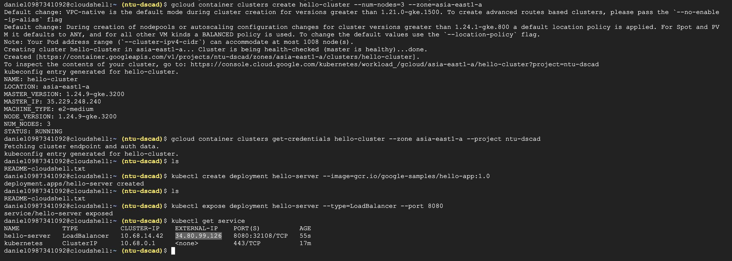

**2.View the application from web browser**

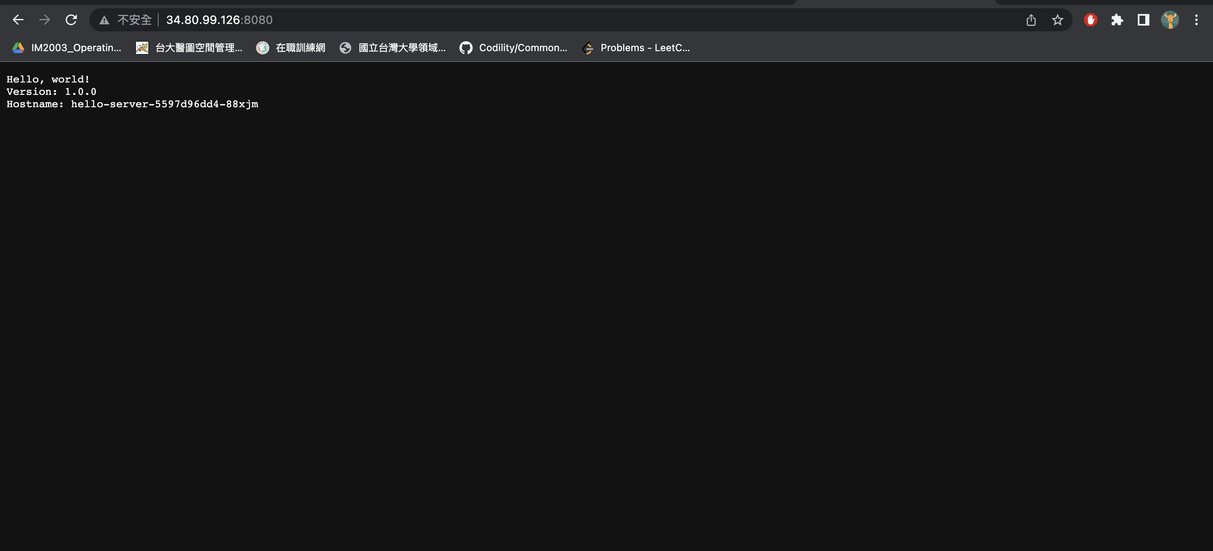

3.Creating Pods

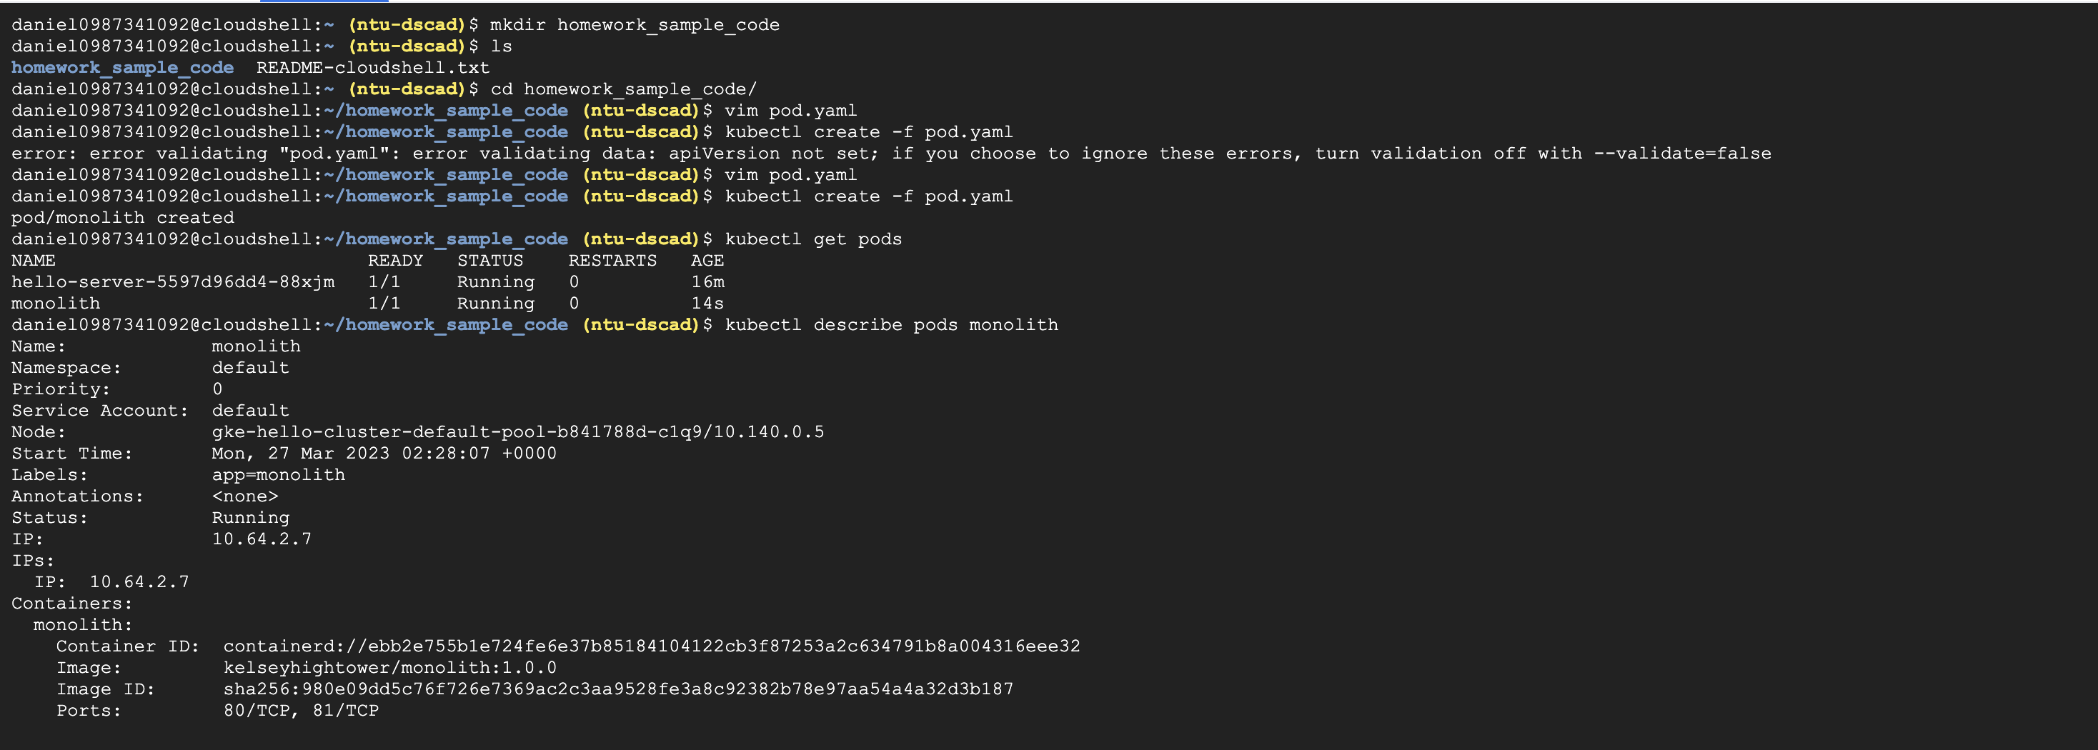

4. Interacting with Pods

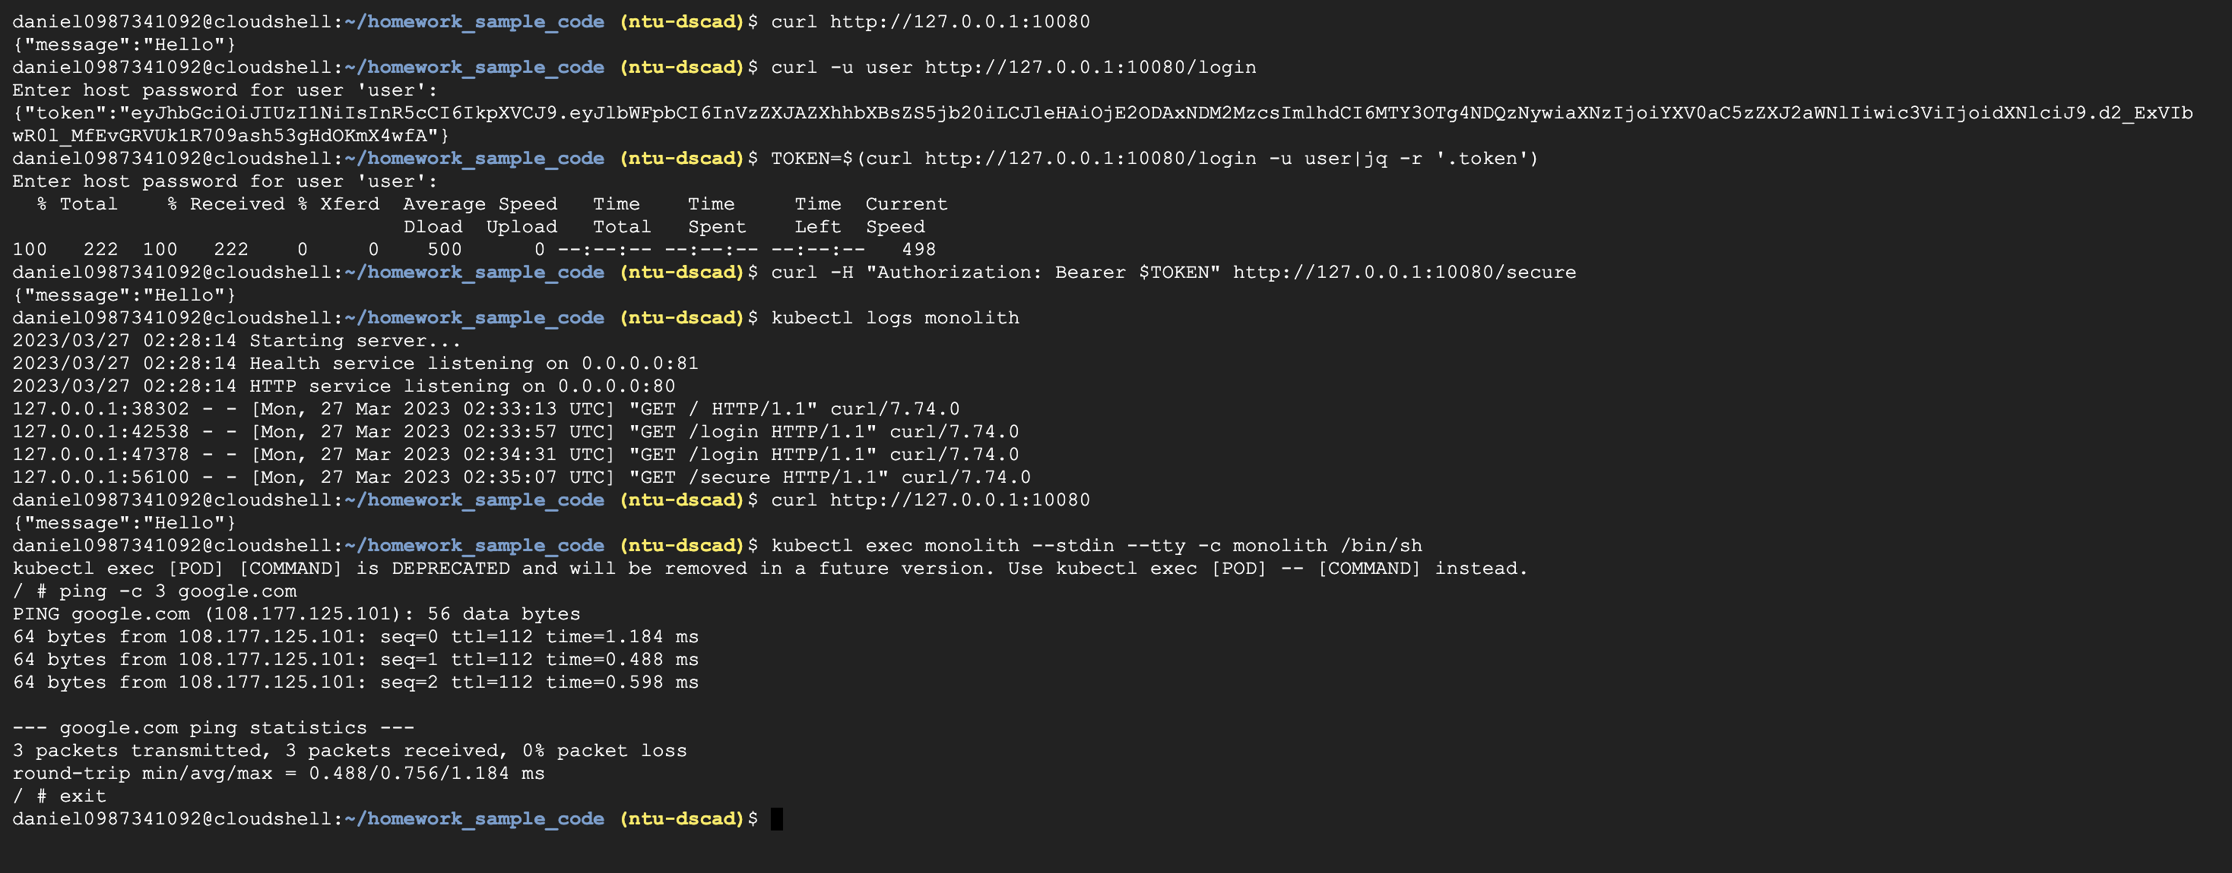

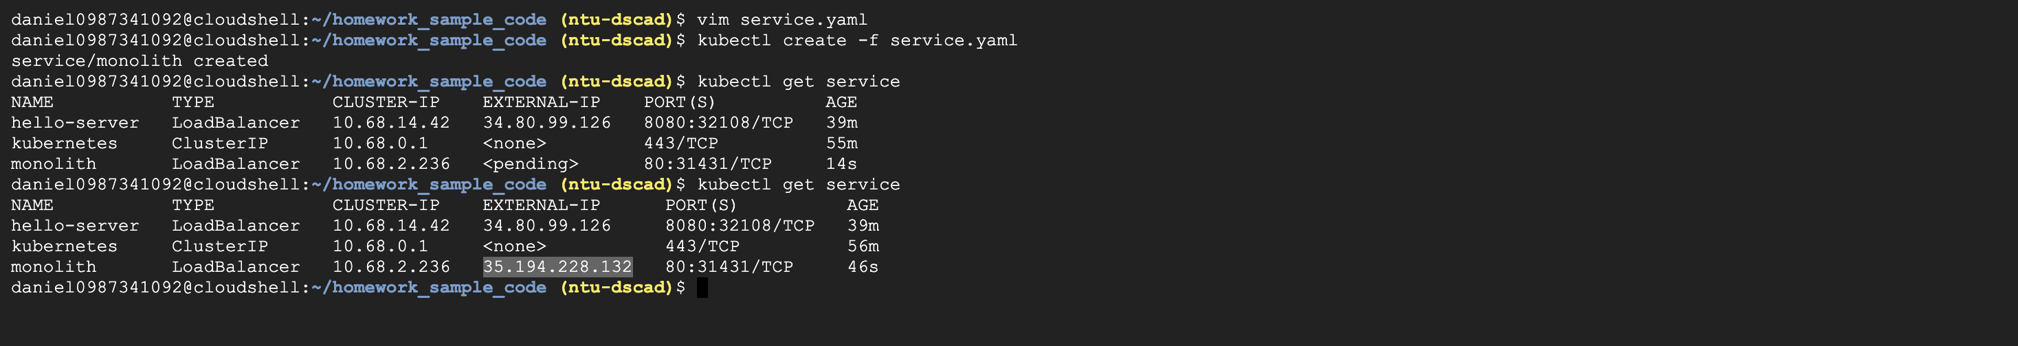

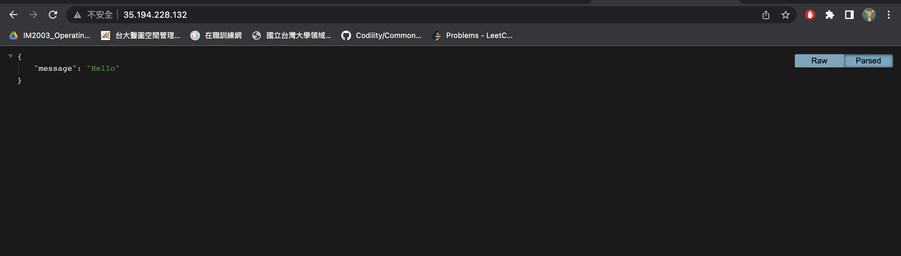

5.Create a Service

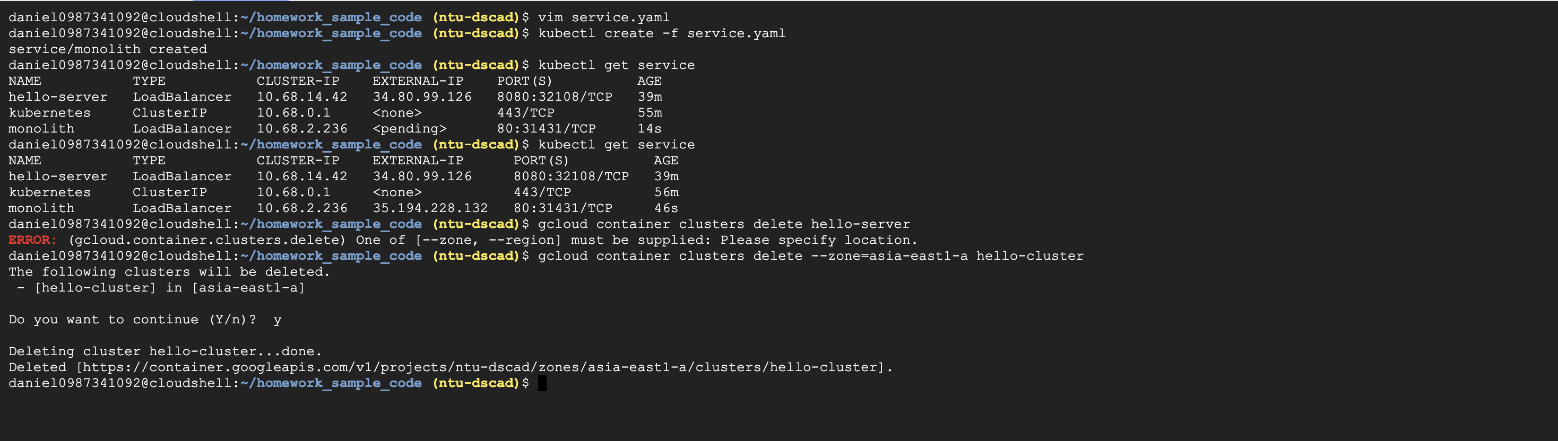

**Implementing Cloud Run canary deployments with Git branches and Cloud Build**

**1.** **Creating your Cloud Run service**

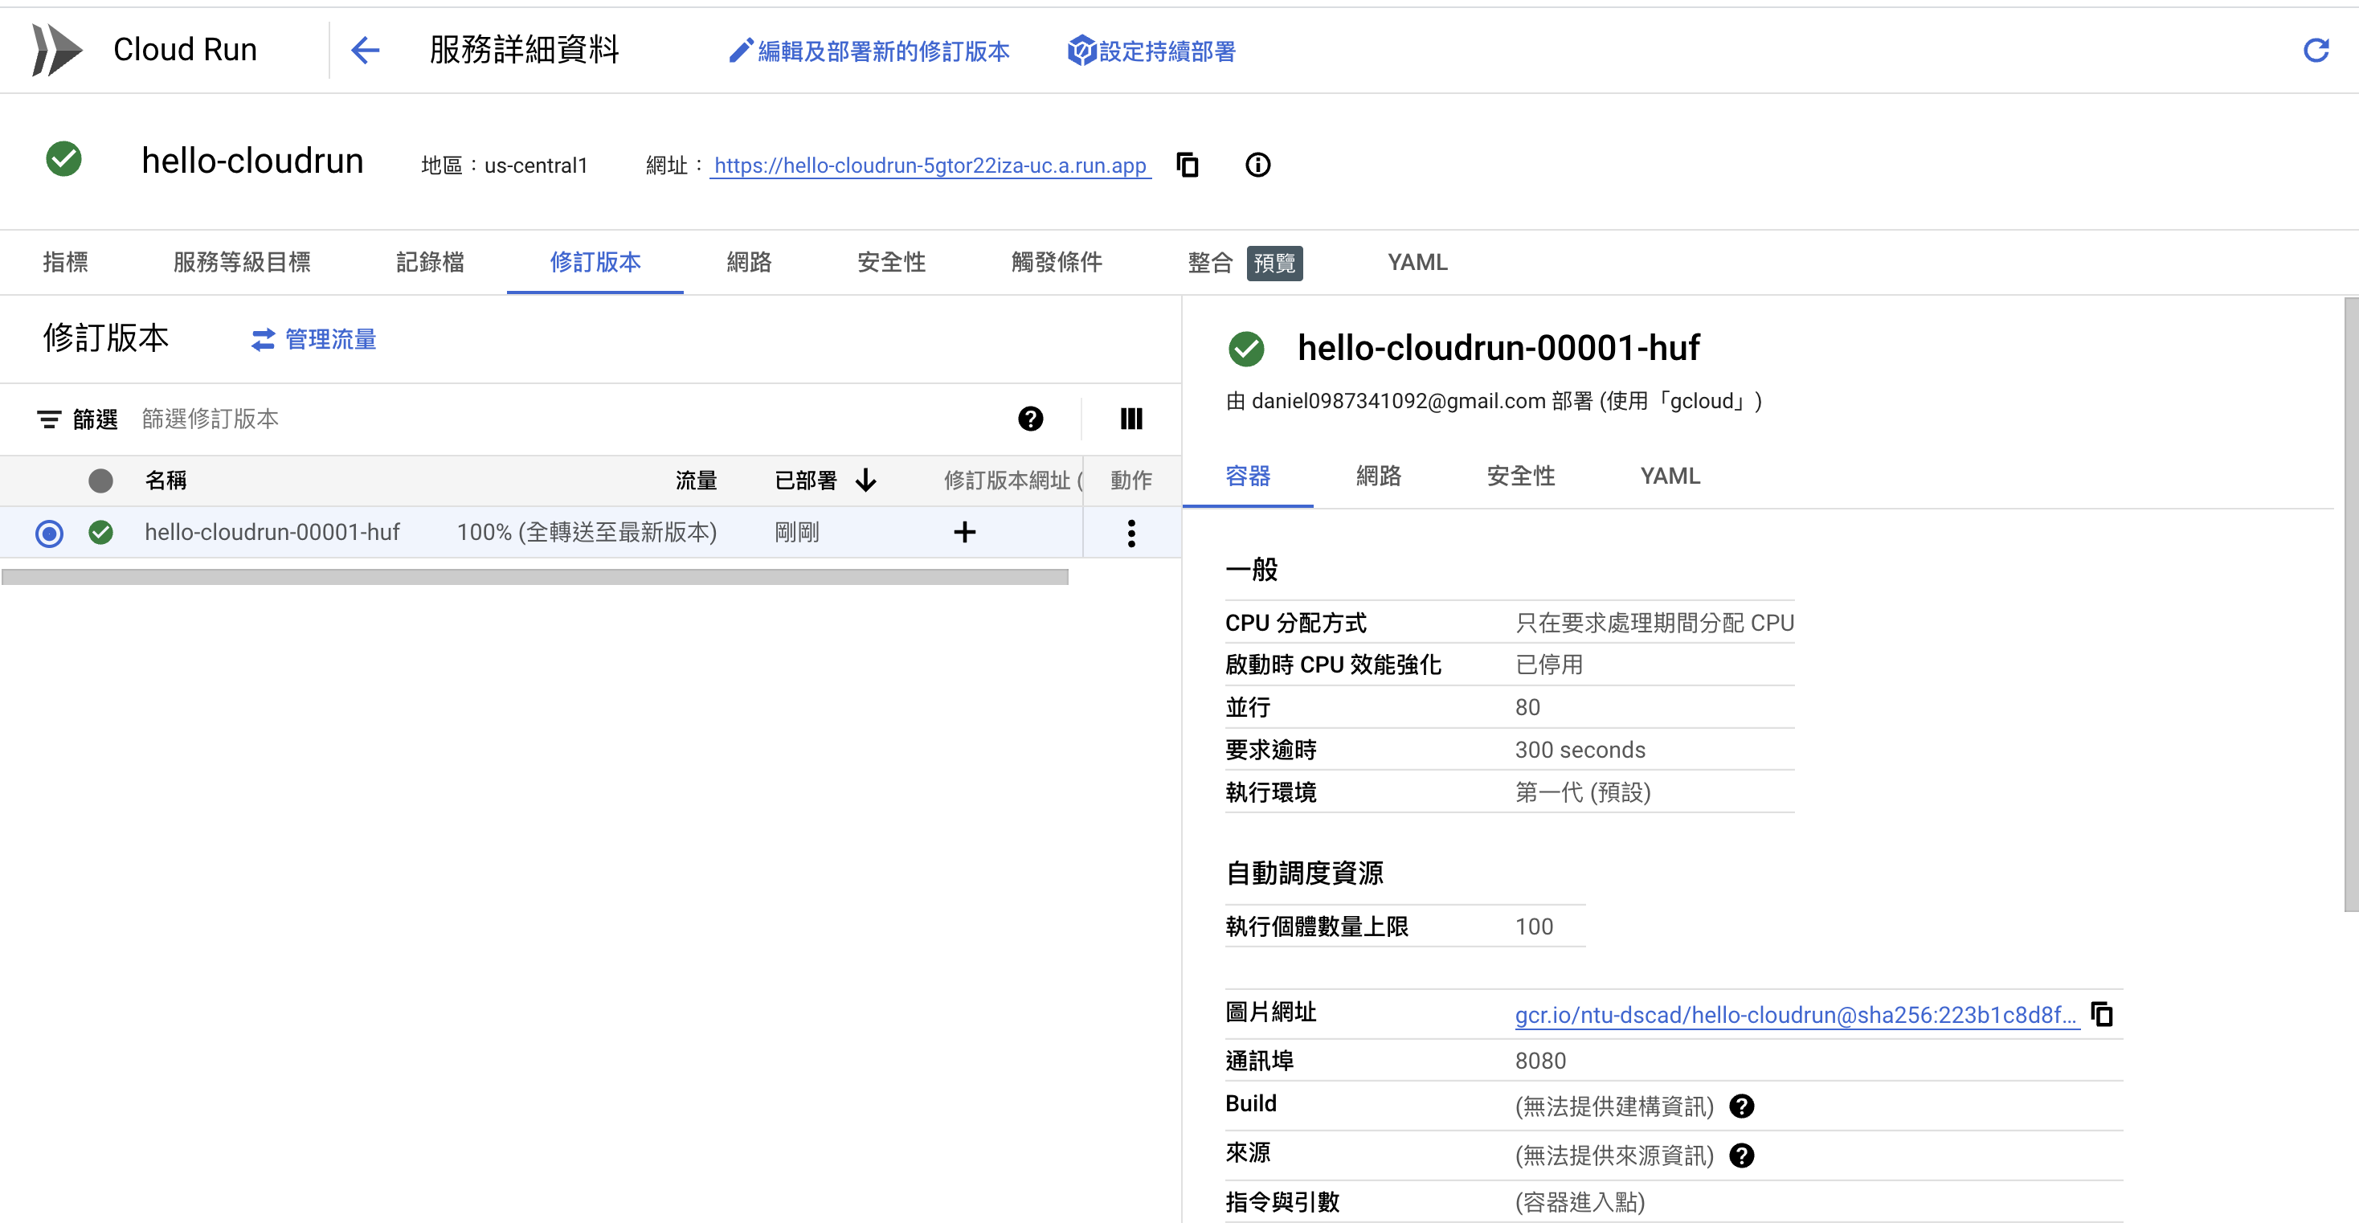

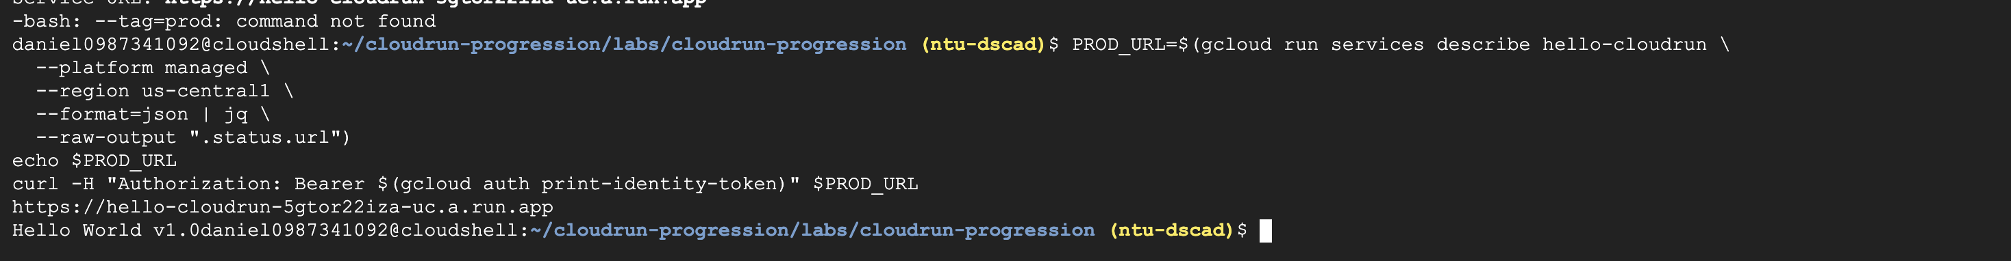

2.Enabling dynamic developer deployments

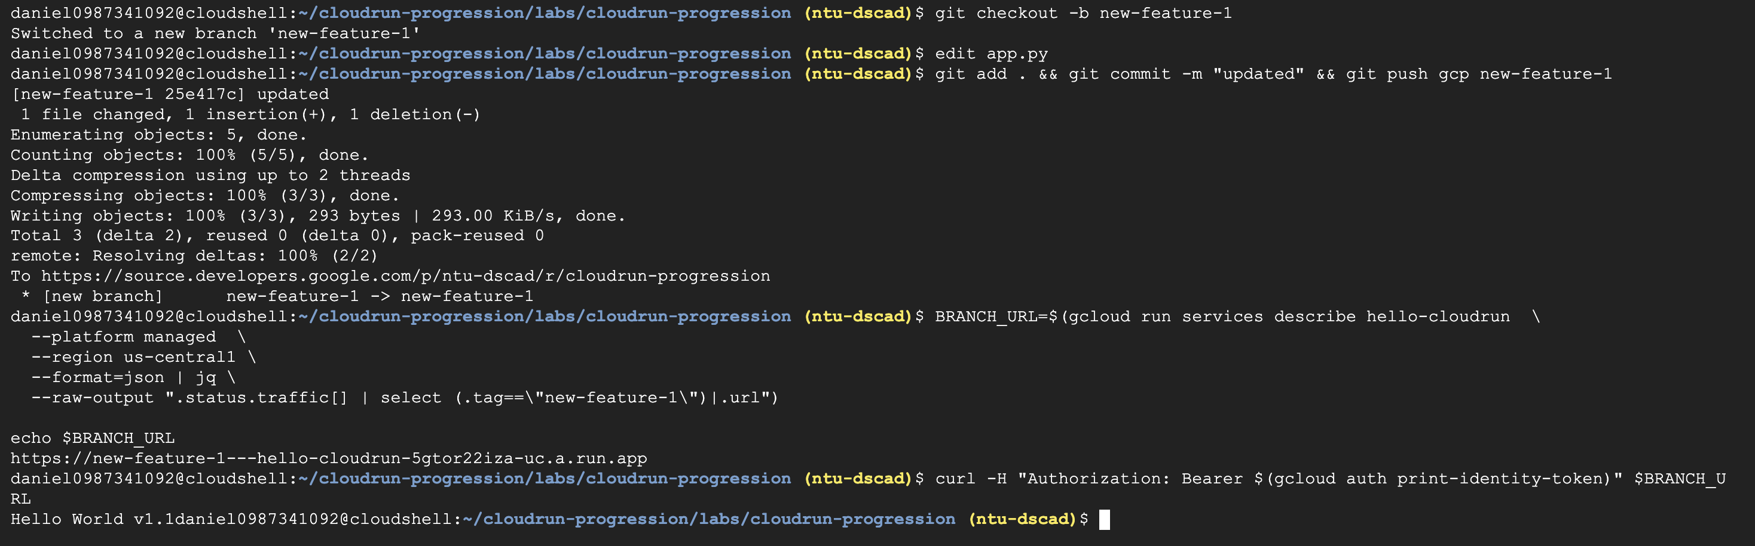

3. commit the change and push to the remote repository

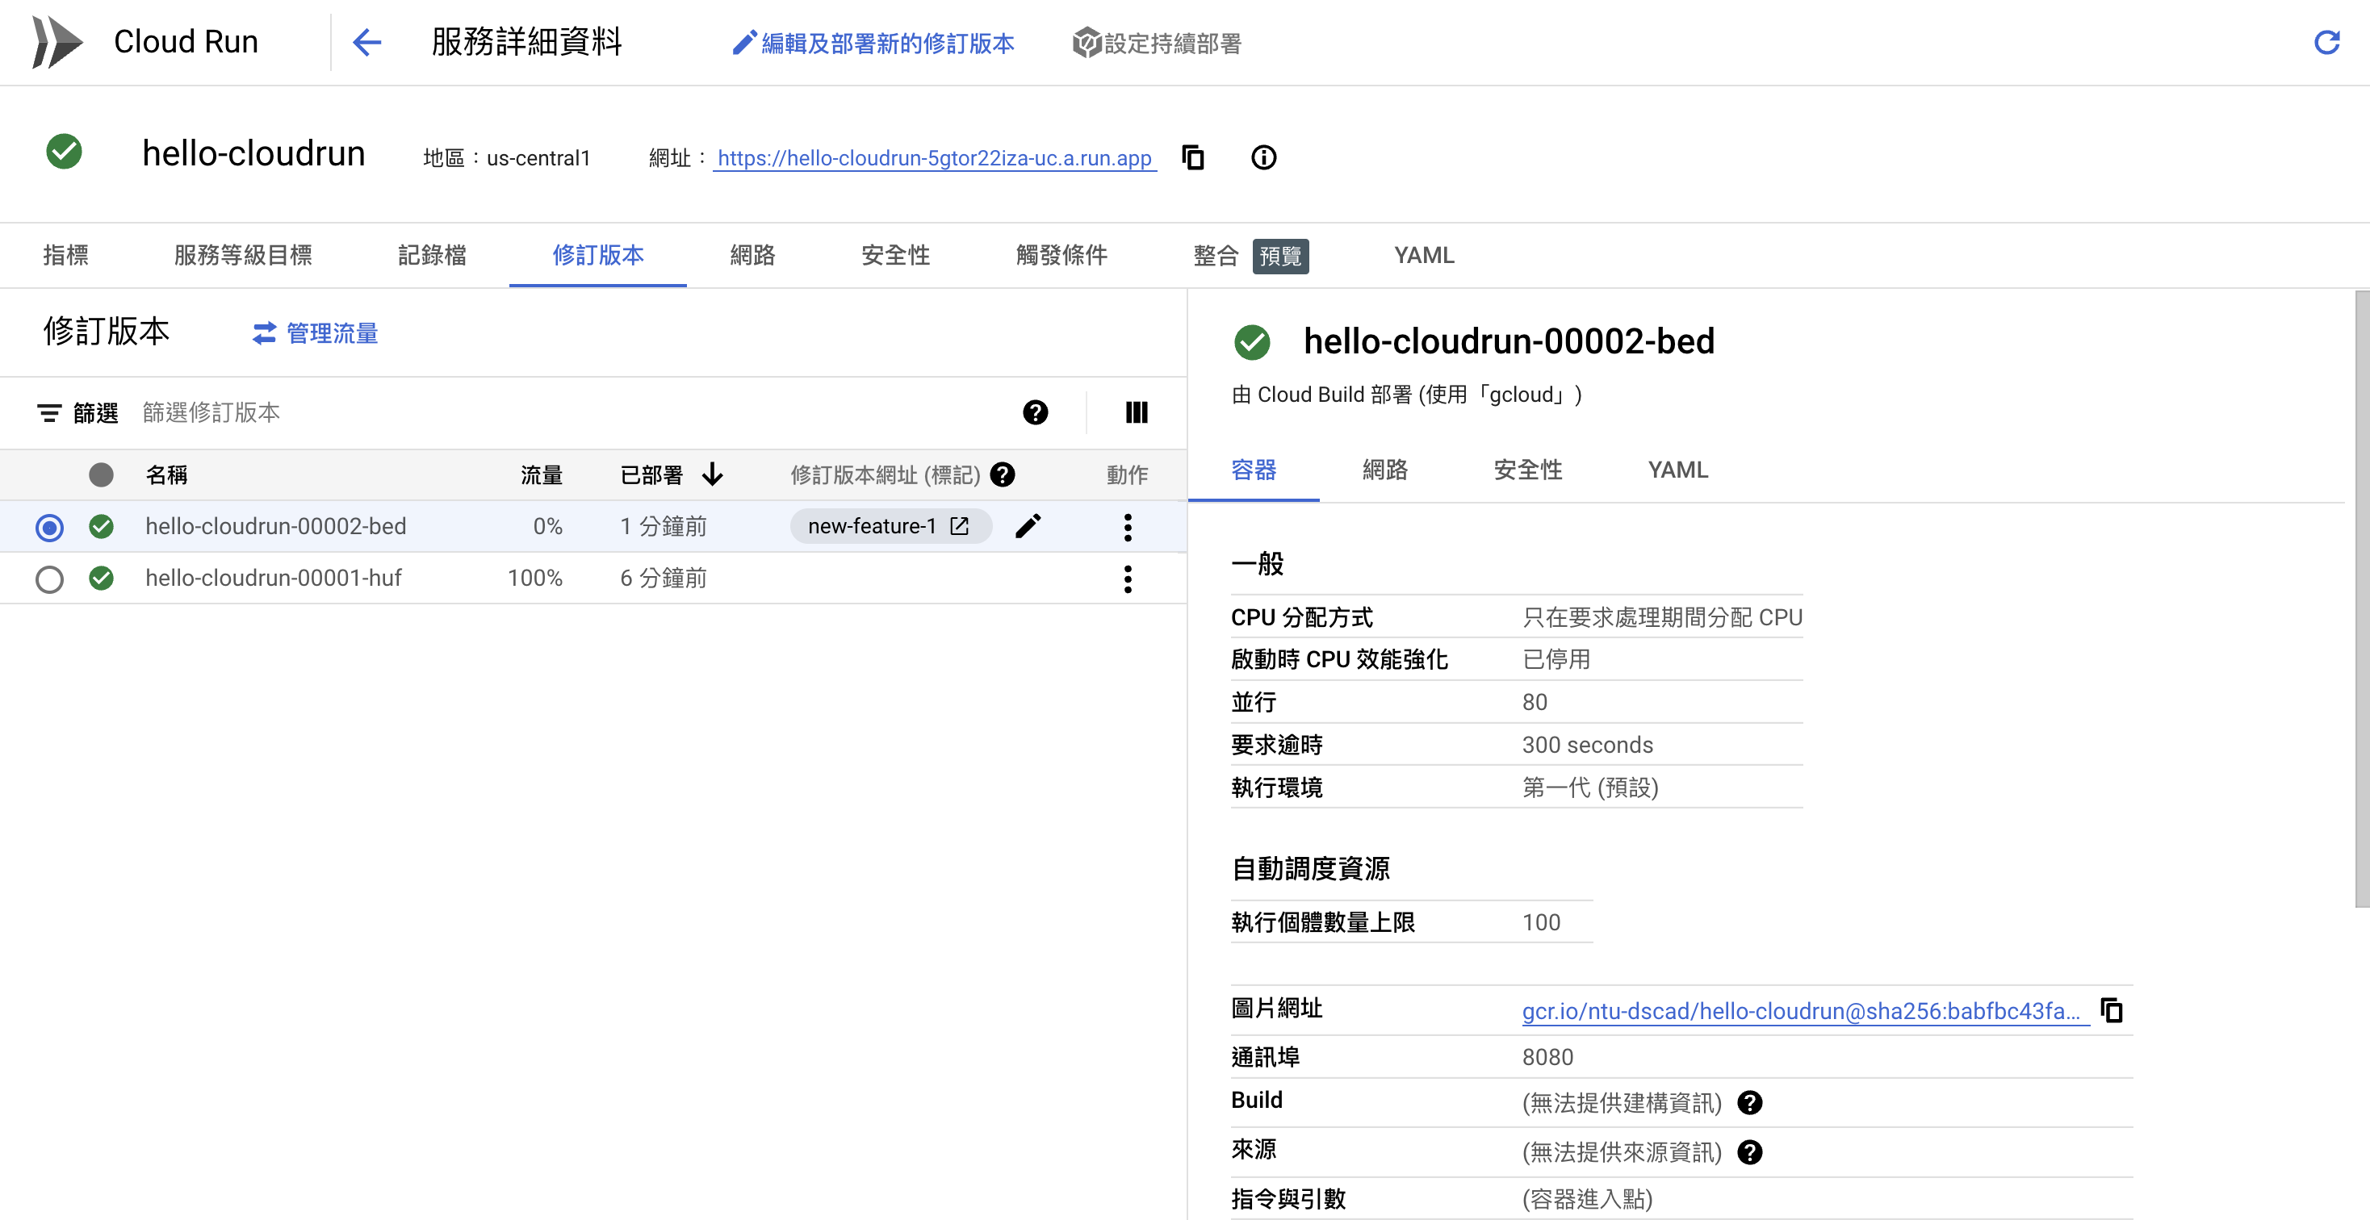

4. 90% of the traffic is routed to **prod**, 10% to **canary**, and 0% to the branch revisions.

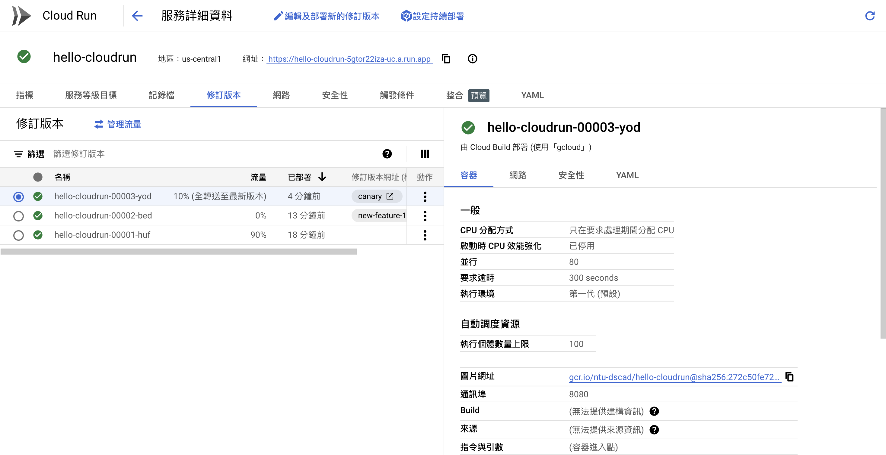

5. see percentage-based responses

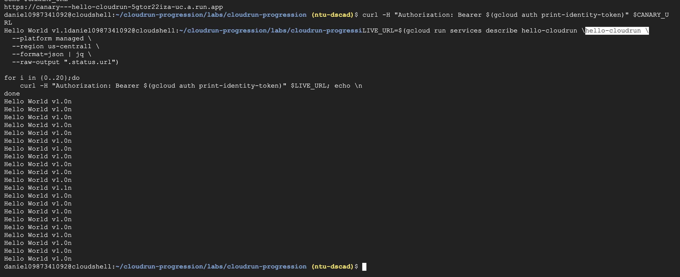6. Releasing to production

